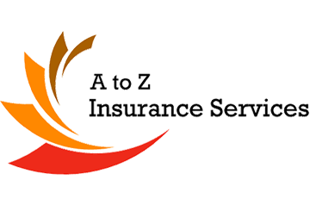
Be Aware of Slip, Trip and Fall Hazards
Be safe and healthy on the job at with these helpful tips provided by A to Z Insurance.

Ways to stay on your feet at the workplace

Wet floors, spills and excess clutter can mean disaster for employees in all kinds of different work settings, causing many workers every year to suffer lost pay and serious pain. Injuries caused by slips, trips and falls range from sprained or strained muscles and joints to broken bones and head injuries. There are several precautions you should take to ensure your safety and the safety of your co-workers.

Floors
- Keep floors clean and dry at all times. Wet floors present a slip hazard and can promote the growth of infection-causing microbes like mould, fungi and bacteria.
- Remove all objects and clutter from aisles, exits and passageways.
- In the event that grease or oil spills on the kitchen floor, clean the mess immediately and alert your co-workers of the problem before they accidentally fall.
- Use floor or ceiling electrical sockets for power to avoid running a cable down a long hallway.
- Display warning signs to alert others of a wet floor.
- Use floor mats while surfaces are drying after cleaning to provide traction.
- Clean up spills immediately.
- In areas prone to slipping (toilet and shower areas), use a anti-slip wax product to clean.
- While washing the floor, wear protective footgear to prevent falling.
- Keep an eye out for uneven floors, and fix them or notify someone who can immediately.

Other Recommendations
- Use ladders to reach high object as opposed to standing on small stools or boxes.
- Stretch out bulging carpets to prevent trips and falls.
- Use handrails while walking down stairs to prevent slipping when walking too fast.
- Repair broken light fixtures and replace bulbs for adequate visibility.

Always Stay Alert
Adopt a see it, sort it mentality. If you notice any situation that you think could present a slipping, tripping or falling hazard for you or a co-worker, act immediately to remedy it or notify your supervisor. You could be saving an unsuspecting victim a lot of lost pay and serious pain.

