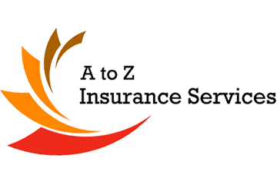
Be Alert for Falling and Flying Objects
Be safe and healthy on the job at with these helpful tips provided by A to Z Insurance.

Helpful tips for preventing injuries on the construction site

Objects falling from above pose a serious hazard on the site, and you are at increased risk when you are beneath cranes or scaffolds, or when others are working above you.

To prevent similar injuries when working around falling and flying hazards, take the following precautions.

Cranes, Hoists and Scaffolds

- Always wear a hard hat.
- Stack materials to prevent sliding, falling or collapse.
- Avoid working underneath cranes, hoists and moving loads.
- Do not exceed the loading capacity of cranes and hoists.
- Secure tools and materials to prevent them from falling on co-workers below.
- Use toe boards, screens and guardrails on scaffolds to prevent objects from falling.
- Use debris nets, catch platforms and canopies to catch or deflect falling objects.
- Do not deliberately throw material from above, even if the worker below is ready to catch the item.
- Do not enter worksites that are restricted due to unsafe conditions.
- Inspect wire ropes, lifting hooks and chains for damage before using cranes and hoists.

Power Tools

- Wear safety goggles, glasses or a face shield when using tools that cause particles to fly.
- Inspect tools to ensure that their protective guards are in good working condition before each use.
- Do not use tools unless you are properly trained on how to do so.

Air Compressors

- Reduce the amount of compressed air used for cleaning to 2.0 bar (30 PSI).
- Only use this machine with the appropriate guarding and protective equipment. Objects can be blown at your body, injuring you.

